**ONLINE BOOK STORE**

Contents

**Main Activity** 2

**Sign Up Activity** 6

**Categories Activity** 10

**Islamic Activity** 15

**Payment Activity** 25

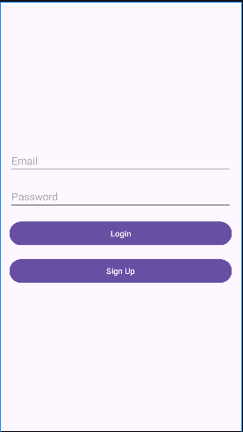

# **Main Activity**

|  |  |
| --- | --- |
| **XML** | **JAVA** |
| <?xml version="1.0" encoding="utf-8"?> <LinearLayout xmlns:android="http://schemas.android.com/apk/res/android"  android:layout_width="match_parent"  android:layout_height="match_parent"  android:orientation="vertical"  android:gravity="center"  android:padding="16dp">   <EditText  android:id="@+id/username"  android:layout_width="match_parent"  android:layout_height="wrap_content"  android:hint="Email"  android:inputType="textEmailAddress"  android:layout_marginBottom="16dp"/>   <EditText  android:id="@+id/password"  android:layout_width="match_parent"  android:layout_height="wrap_content"  android:hint="Password"  android:inputType="textPassword"  android:layout_marginBottom="16dp"/>   <Button  android:id="@+id/loginButton"  android:layout_width="match_parent"  android:layout_height="wrap_content"  android:text="Login"  android:layout_marginBottom="16dp"/>   <Button  android:id="@+id/signupButton"  android:layout_width="match_parent"  android:layout_height="wrap_content"  android:text="Sign Up" /> </LinearLayout> | package com.example.bookstoreproject;  import android.content.Intent; import android.os.Bundle; import android.view.View; import android.widget.Button; import androidx.appcompat.app.AppCompatActivity;  public class MainActivity extends AppCompatActivity {  @Override  protected void onCreate(Bundle savedInstanceState) {  super.onCreate(savedInstanceState);  setContentView(R.layout.activity_main);   Button loginButton = findViewById(R.id.loginButton);  Button registerButton = findViewById(R.id.signupButton);   loginButton.setOnClickListener(new View.OnClickListener() {  @Override  public void onClick(View v) {  Intent intent = new Intent(MainActivity.this, CategoriesActivity.class);  startActivity(intent);  }  });   registerButton.setOnClickListener(new View.OnClickListener() {  @Override  public void onClick(View v) {  Intent intent = new Intent(MainActivity.this, SignupActivity.class);  startActivity(intent);  }  });  } } |

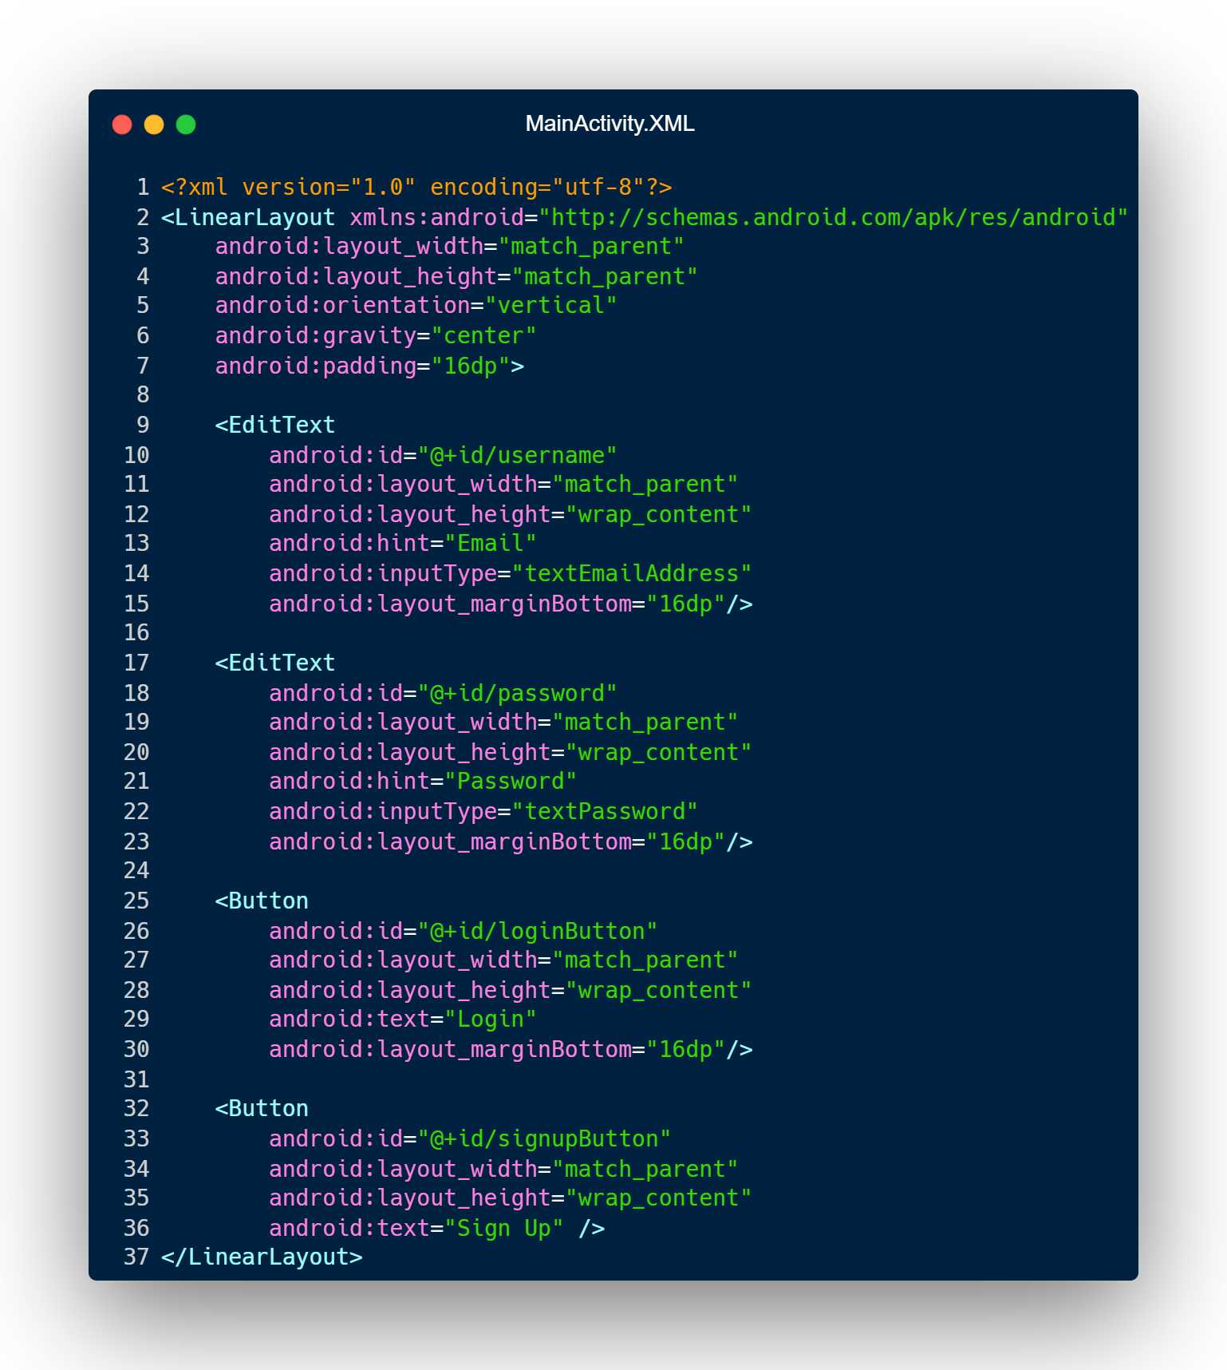

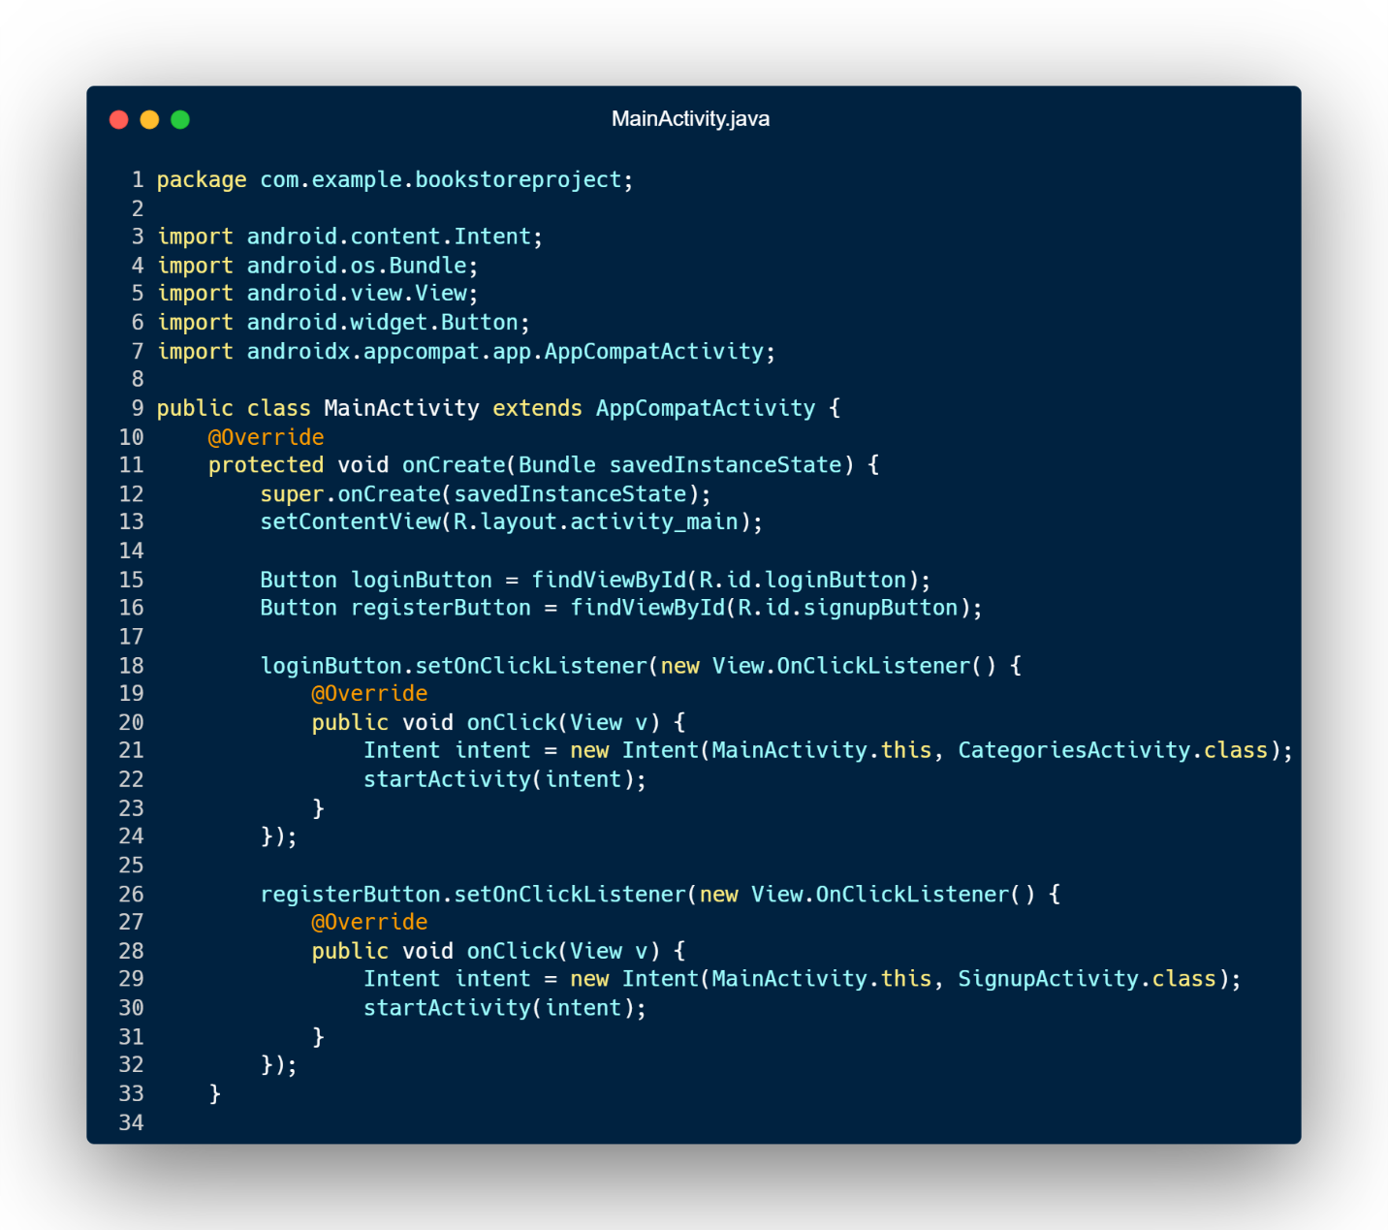

Main Activity Declaration

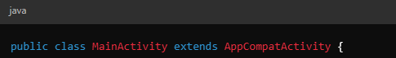

onCreate() Method

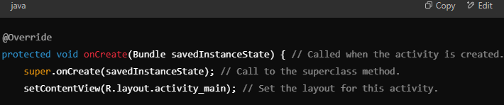

Set Login Button Click Listener

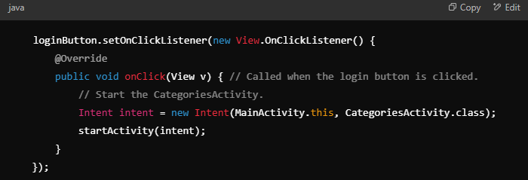

Set Register Button Click Listener

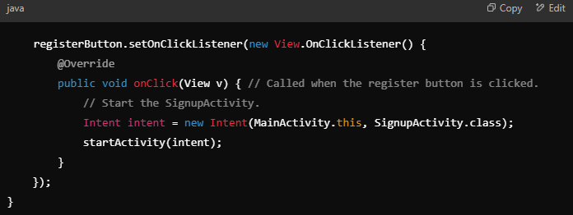

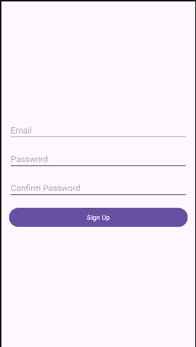

# **Sign Up Activity**

|  |  |  |
| --- | --- | --- |
| **XML** | | **JAVA** |
| package com.example.bookstoreproject;  import android.content.Intent; import android.os.Bundle; import android.view.View; import android.widget.Button; import android.widget.EditText; import android.widget.Toast; import androidx.appcompat.app.AppCompatActivity;  public class SignupActivity extends AppCompatActivity {   private EditText username, password, confirmPassword;  private Button signupButton;   @Override  protected void onCreate(Bundle savedInstanceState) {  super.onCreate(savedInstanceState);  setContentView(R.layout.activity_signup);   username = findViewById(R.id.username);  password = findViewById(R.id.password);  confirmPassword = findViewById(R.id.confirmPassword);  signupButton = findViewById(R.id.signupButton);   signupButton.setOnClickListener(new View.OnClickListener() {  @Override  public void onClick(View v) {  String email = username.getText().toString().trim();  String pass = password.getText().toString().trim();  String confirmPass = confirmPassword.getText().toString().trim();   if (email.isEmpty() || pass.isEmpty() || confirmPass.isEmpty()) {  Toast.makeText(SignupActivity.this, "Please fill all fields", Toast.LENGTH_SHORT).show();  } else if (!pass.equals(confirmPass)) {  Toast.makeText(SignupActivity.this, "Passwords do not match", Toast.LENGTH_SHORT).show();  } else {  // Simulate a successful signup  Toast.makeText(SignupActivity.this, "Signup Successful", Toast.LENGTH_SHORT).show();  Intent intent = new Intent(SignupActivity.this, CategoriesActivity.class);  startActivity(intent);  finish();  }  }  });  } } |

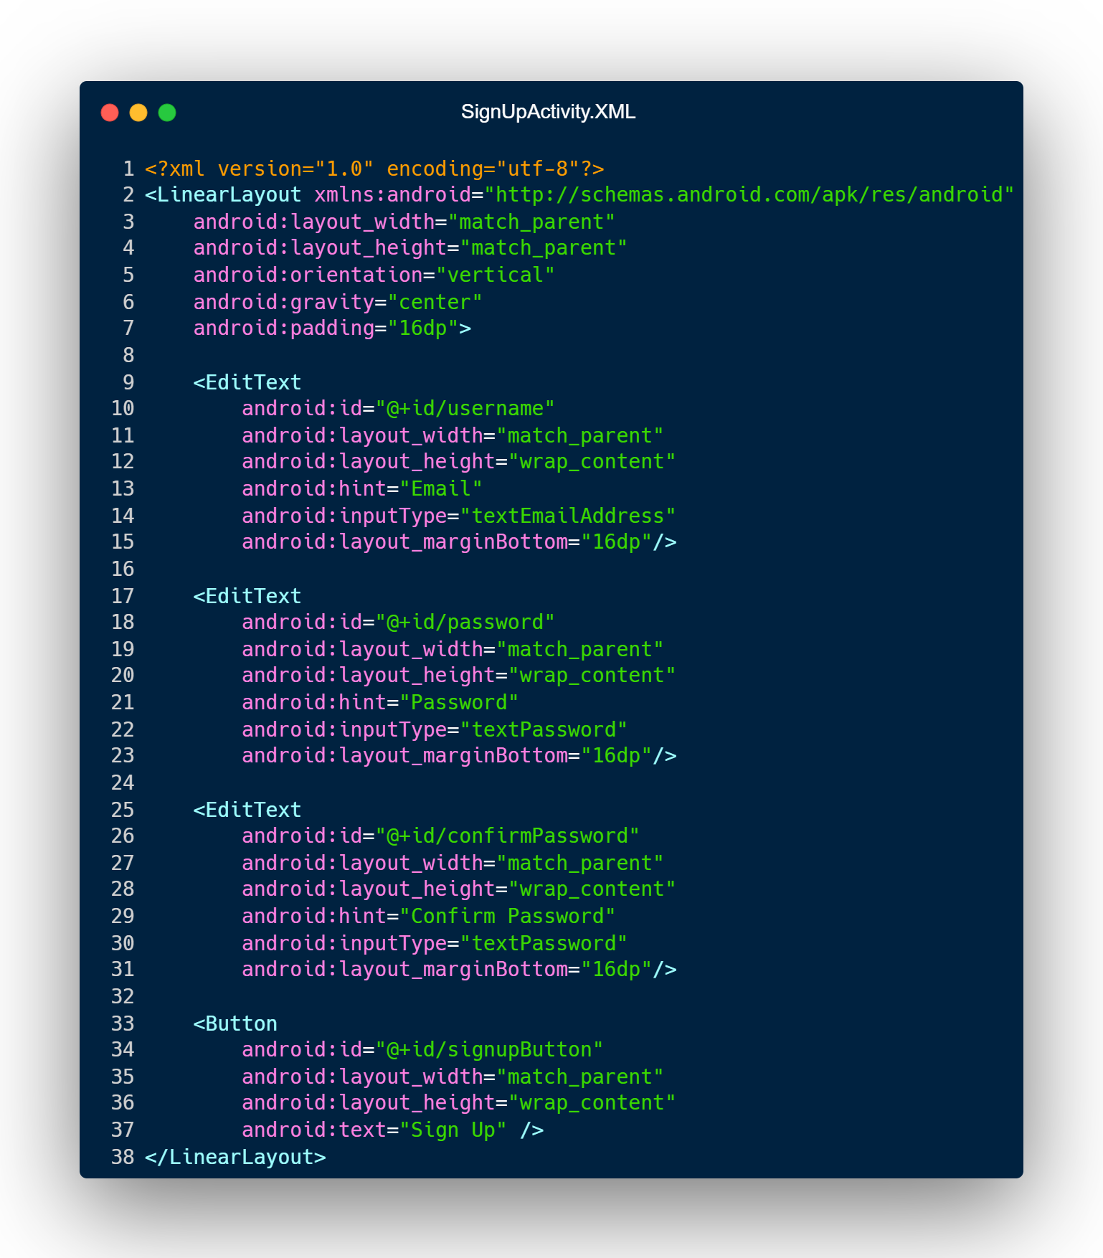

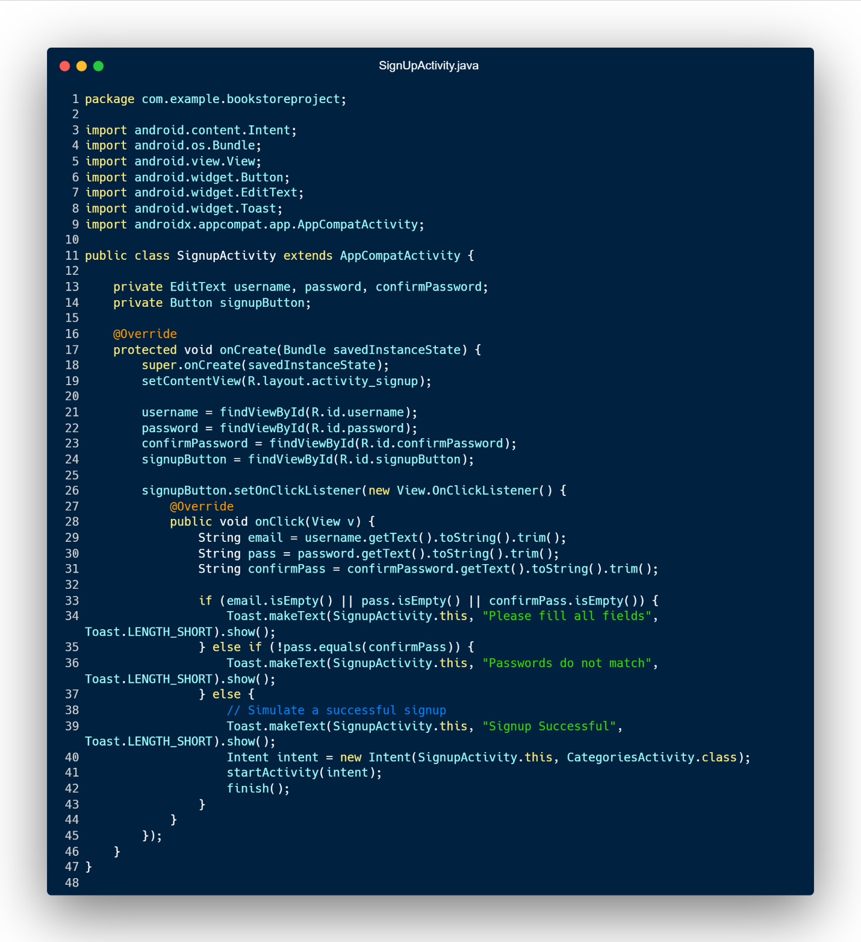

# **Categories Activity**

|  |  |
| --- | --- |
| **XML** | **JAVA** |
| <?xml version="1.0" encoding="utf-8"?> <androidx.constraintlayout.widget.ConstraintLayout xmlns:android="http://schemas.android.com/apk/res/android"  xmlns:app="http://schemas.android.com/apk/res-auto"  xmlns:tools="http://schemas.android.com/tools"  android:id="@+id/main"  android:layout_width="match_parent"  android:layout_height="match_parent"  tools:context=".CategoriesActivity">   <ListView  android:id="@+id/listView"  android:layout_width="match_parent"  android:layout_height="match_parent"  android:cacheColorHint="#FFFFFF"  app:layout_constraintBottom_toBottomOf="parent"  app:layout_constraintEnd_toEndOf="parent"  app:layout_constraintStart_toStartOf="parent" />  </androidx.constraintlayout.widget.ConstraintLayout> | package com.example.bookstoreproject;  import android.content.Intent; import android.os.Bundle; import android.view.View; import android.widget.AdapterView; import android.widget.ArrayAdapter; import android.widget.ListView;  import androidx.appcompat.app.AppCompatActivity;  import java.util.ArrayList; import java.util.List;  public class CategoriesActivity extends AppCompatActivity {   @Override  protected void onCreate(Bundle savedInstanceState) {  super.onCreate(savedInstanceState);  setContentView(R.layout.activity_categories);   // List of categories  List<String> list = new ArrayList<>();  list.add("Islamic");  list.add("History");  list.add("Fantasy");  list.add("Travel");  list.add("Horror");  list.add("Thriller");  list.add("Health & Fitness");  list.add("Romance");  list.add("Mystery");  list.add("Children's Books");  list.add("Cooking");  list.add("Technology");  list.add("Sports");  list.add("Fiction");  list.add("Non-Fiction");  list.add("Politics");  list.add("Music");  list.add("Spirituality");  list.add("Drama");  list.add("Humor");  list.add("Crime");  list.add("Economics");  list.add("Animals & Nature");   // Get the ListView  ListView listView = findViewById(R.id.listView);   // Create an ArrayAdapter  ArrayAdapter<String> arrayAdapter = new ArrayAdapter<>(  getApplicationContext(),  android.R.layout.simple_list_item_1,  list  );   // Set the adapter to the ListView  listView.setAdapter(arrayAdapter);   // Set an item click listener for the ListView  listView.setOnItemClickListener(new AdapterView.OnItemClickListener() {  @Override  public void onItemClick(AdapterView<?> parent, View view, int position, long id) {  if (position == 0) {  // Clicked Islamic  startActivity(new Intent(CategoriesActivity.this, Islamic.class));  } else if (position == 1) {  // Clicked History  startActivity(new Intent(CategoriesActivity.this, History.class));  }  else if (position == 2) {  // Clicked Fantasy  startActivity(new Intent(CategoriesActivity.this, Fantasy.class));  }  }  });  } } |

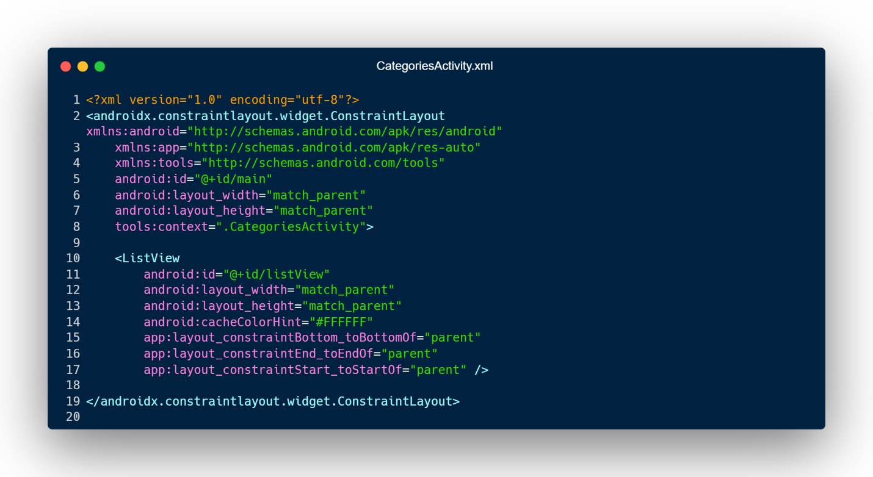

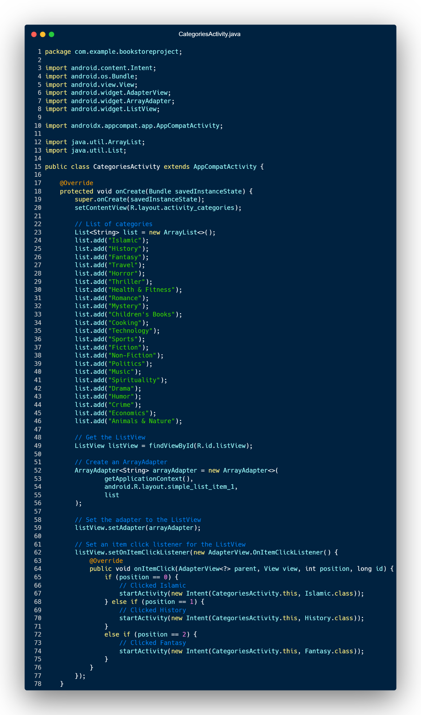



# **Islamic Activity**

|  |  |
| --- | --- |
| **XML** | **JAVA** |
| <?xml version="1.0" encoding="utf-8"?> <ScrollView  xmlns:android="http://schemas.android.com/apk/res/android"  xmlns:app="http://schemas.android.com/apk/res-auto"  xmlns:tools="http://schemas.android.com/tools"  android:layout_width="match_parent"  android:layout_height="wrap_content"  android:fillViewport="true"  tools:context=".Islamic">   <LinearLayout  android:id="@+id/main"  android:layout_width="match_parent"  android:layout_height="wrap_content"  android:orientation="vertical">   <!-- Title -->  <TextView  android:id="@+id/detailName"  android:layout_width="wrap_content"  android:layout_height="wrap_content"  android:layout_marginTop="14dp"  android:layout_gravity="center"  android:text="Islamic Books"  android:textColor="@color/black"  android:textSize="24sp"  android:textStyle="bold" />   <!--Basic Code Structure Start Hare-->  <!-- First Book Card -->  <androidx.cardview.widget.CardView  android:id="@+id/cardImage"  android:layout_width="380dp"  android:layout_height="200dp"  android:layout_gravity="center"  app:cardCornerRadius="20dp"  app:cardElevation="8dp">   <ImageView  android:id="@+id/detailImage"  android:layout_width="match_parent"  android:layout_height="match_parent"  android:src= "@drawable/tareek_e_islam_akbar_shah_urdu_hasanat"  android:scaleType="fitCenter" />   </androidx.cardview.widget.CardView>   <!-- Book Details -->  <TextView  android:id="@+id/detailBreadcrumb"  android:layout_width="wrap_content"  android:layout_height="wrap_content"  android:layout_marginStart="10dp"  android:text="Home / Categories / Islamic Books"  android:textColor="#454746"  android:textSize="16sp" />   <TextView  android:id="@+id/detailTitle"  android:layout_width="wrap_content"  android:layout_height="wrap_content"  android:layout_marginStart="10dp"  android:layout_marginTop="20dp"  android:text="Title"  android:textColor="@color/cardview_dark_background"  android:textSize="18sp"  android:textStyle="bold" />   <TextView  android:id="@+id/detailDescription"  android:layout_width="wrap_content"  android:layout_height="wrap_content"  android:layout_marginStart="10dp"  android:text="Tareek-E-Islam Akbar Shah Urdu Hasanat"  android:textColor="@color/black"  android:textSize="16sp" />   <TextView  android:id="@+id/priceTitle"  android:layout_width="wrap_content"  android:layout_height="wrap_content"  android:layout_marginStart="10dp"  android:layout_marginTop="20dp"  android:text="Price"  android:textColor="@color/cardview_dark_background"  android:textSize="18sp"  android:textStyle="bold" />   <TextView  android:id="@+id/detailPrice"  android:layout_width="wrap_content"  android:layout_height="wrap_content"  android:layout_marginStart="10dp"  android:text="Rs.2,999 Only"  android:textColor="#FF061F"  android:textSize="16sp"  android:textStyle="bold" />   <TextView  android:id="@+id/descriptionTitle"  android:layout_width="wrap_content"  android:layout_height="wrap_content"  android:layout_marginStart="10dp"  android:layout_marginTop="20dp"  android:text="Description"  android:textColor="@color/cardview_dark_background"  android:textSize="18sp"  android:textStyle="bold" />   <TextView  android:id="@+id/detailBookDescription"  android:layout_width="wrap_content"  android:layout_height="wrap_content"  android:layout_marginStart="10dp"  android:text="Tareekhe Islam Jild Awwal Wa Daum (Murakh Islam Akbar Shah Khan Najeeb Aabadi) Al Hasanat Urdu"  android:textColor="@color/black"  android:textSize="16sp" />   <TextView  android:id="@+id/languageTitle"  android:layout_width="wrap_content"  android:layout_height="wrap_content"  android:layout_marginStart="10dp"  android:layout_marginTop="5dp"  android:text="Language"  android:textColor="@color/cardview_dark_background"  android:textSize="18sp"  android:textStyle="bold" />   <TextView  android:id="@+id/detailLanguage"  android:layout_width="wrap_content"  android:layout_height="wrap_content"  android:layout_marginStart="10dp"  android:text="Urdu"  android:textColor="@color/black"  android:textSize="16sp" />   <TextView  android:id="@+id/publisherTitle"  android:layout_width="wrap_content"  android:layout_height="wrap_content"  android:layout_marginStart="10dp"  android:layout_marginTop="5dp"  android:text="Publisher"  android:textColor="@color/cardview_dark_background"  android:textSize="18sp"  android:textStyle="bold" />   <TextView  android:id="@+id/detailPublisher"  android:layout_width="wrap_content"  android:layout_height="wrap_content"  android:layout_marginStart="10dp"  android:text="Al Hasanat Books Pvt. Ltd."  android:textColor="@color/black"  android:textSize="16sp" />   <TextView  android:id="@+id/pagesTitle"  android:layout_width="wrap_content"  android:layout_height="wrap_content"  android:layout_marginStart="10dp"  android:layout_marginTop="5dp"  android:text="Pages"  android:textColor="@color/cardview_dark_background"  android:textSize="18sp"  android:textStyle="bold" />   <TextView  android:id="@+id/detailPages"  android:layout_width="wrap_content"  android:layout_height="wrap_content"  android:layout_marginStart="10dp"  android:text="992"  android:textColor="@color/black"  android:textSize="16sp" />   <!-- Buttons -->  <LinearLayout  android:layout_width="match_parent"  android:layout_height="wrap_content"  android:orientation="horizontal"  android:gravity="center"  android:layout_marginTop="20dp">   <Button  android:id="@+id/addToCartButton"  android:layout_width="0dp"  android:layout_height="60dp"  android:layout_weight="1"  android:layout_marginEnd="10dp"  android:text="Add To Cart"  android:textColor="@color/white"  android:textStyle="bold"  android:backgroundTint="#673AB7" />   <Button  android:id="@+id/checkoutButton"  android:layout_width="0dp"  android:layout_height="60dp"  android:layout_weight="1"  android:layout_marginStart="10dp"  android:text="Checkout"  android:textColor="@color/white"  android:textStyle="bold"  android:backgroundTint="#673AB7" />  </LinearLayout>   <!--Basic Code Structure Start Hare-->  <!-- First Book Card -->  <!-- Basic Code Structure Start Here -->  <!-- First Book Card -->  <androidx.cardview.widget.CardView  android:id="@+id/bookCardView"  android:layout_width="380dp"  android:layout_height="200dp"  android:layout_gravity="center"  app:cardCornerRadius="20dp"  app:cardElevation="8dp">   <ImageView  android:id="@+id/bookImage"  android:layout_width="match_parent"  android:layout_height="match_parent"  android:src= "@drawable/tareek_e_islam_akbar_shah_urdu_hasanat"  android:scaleType="fitCenter" />  </androidx.cardview.widget.CardView>   <!-- Book Details -->  <TextView  android:id="@+id/breadcrumbText"  android:layout_width="wrap_content"  android:layout_height="wrap_content"  android:layout_marginStart="10dp"  android:text="Home / Categories / Islamic Books"  android:textColor="#454746"  android:textSize="16sp" />   <TextView  android:id="@+id/bookTitleText"  android:layout_width="wrap_content"  android:layout_height="wrap_content"  android:layout_marginStart="10dp"  android:layout_marginTop="20dp"  android:text="Title"  android:textColor="@color/cardview_dark_background"  android:textSize="18sp"  android:textStyle="bold" />   <TextView  android:id="@+id/bookSubtitleText"  android:layout_width="wrap_content"  android:layout_height="wrap_content"  android:layout_marginStart="10dp"  android:text="Tareek-E-Islam Akbar Shah Urdu Hasanat"  android:textColor="@color/black"  android:textSize="16sp" />   <TextView  android:id="@+id/priceLabel"  android:layout_width="wrap_content"  android:layout_height="wrap_content"  android:layout_marginStart="10dp"  android:layout_marginTop="20dp"  android:text="Price"  android:textColor="@color/cardview_dark_background"  android:textSize="18sp"  android:textStyle="bold" />   <TextView  android:id="@+id/bookPriceText"  android:layout_width="wrap_content"  android:layout_height="wrap_content"  android:layout_marginStart="10dp"  android:text="Rs.2,999 Only"  android:textColor="#FF061F"  android:textSize="16sp"  android:textStyle="bold" />   <TextView  android:id="@+id/descriptionLabel"  android:layout_width="wrap_content"  android:layout_height="wrap_content"  android:layout_marginStart="10dp"  android:layout_marginTop="20dp"  android:text="Description"  android:textColor="@color/cardview_dark_background"  android:textSize="18sp"  android:textStyle="bold" />   <TextView  android:id="@+id/bookDescriptionText"  android:layout_width="wrap_content"  android:layout_height="wrap_content"  android:layout_marginStart="10dp"  android:text="Tareekhe Islam Jild Awwal Wa Daum (Murakh Islam Akbar Shah Khan Najeeb Aabadi) Al Hasanat Urdu"  android:textColor="@color/black"  android:textSize="16sp" />   <TextView  android:id="@+id/languageLabel"  android:layout_width="wrap_content"  android:layout_height="wrap_content"  android:layout_marginStart="10dp"  android:layout_marginTop="5dp"  android:text="Language"  android:textColor="@color/cardview_dark_background"  android:textSize="18sp"  android:textStyle="bold" />   <TextView  android:id="@+id/bookLanguageText"  android:layout_width="wrap_content"  android:layout_height="wrap_content"  android:layout_marginStart="10dp"  android:text="Urdu"  android:textColor="@color/black"  android:textSize="16sp" />   <TextView  android:id="@+id/publisherLabel"  android:layout_width="wrap_content"  android:layout_height="wrap_content"  android:layout_marginStart="10dp"  android:layout_marginTop="5dp"  android:text="Publisher"  android:textColor="@color/cardview_dark_background"  android:textSize="18sp"  android:textStyle="bold" />   <TextView  android:id="@+id/bookPublisherText"  android:layout_width="wrap_content"  android:layout_height="wrap_content"  android:layout_marginStart="10dp"  android:text="Al Hasanat Books Pvt. Ltd."  android:textColor="@color/black"  android:textSize="16sp" />   <TextView  android:id="@+id/pagesLabel"  android:layout_width="wrap_content"  android:layout_height="wrap_content"  android:layout_marginStart="10dp"  android:layout_marginTop="5dp"  android:text="Pages"  android:textColor="@color/cardview_dark_background"  android:textSize="18sp"  android:textStyle="bold" />   <TextView  android:id="@+id/bookPagesText"  android:layout_width="wrap_content"  android:layout_height="wrap_content"  android:layout_marginStart="10dp"  android:text="992"  android:textColor="@color/black"  android:textSize="16sp" />   <!-- Buttons -->  <LinearLayout  android:layout_width="match_parent"  android:layout_height="wrap_content"  android:orientation="horizontal"  android:gravity="center"  android:layout_marginTop="20dp">   <Button  android:id="@+id/addToCartBtn"  android:layout_width="0dp"  android:layout_height="60dp"  android:layout_weight="1"  android:layout_marginEnd="10dp"  android:text="Add To Cart"  android:textColor="@color/white"  android:textStyle="bold"  android:backgroundTint="#673AB7" />   <Button  android:id="@+id/checkoutButton"  android:layout_width="0dp"  android:layout_height="60dp"  android:layout_weight="1"  android:layout_marginStart="10dp"  android:text="Checkout"  android:textColor="@color/white"  android:textStyle="bold"  android:backgroundTint="#673AB7" />  </LinearLayout>   </LinearLayout> </ScrollView> | package com.example.bookstoreproject;  import android.content.Intent; import android.os.Bundle; import android.view.View; import android.widget.Button;  import androidx.activity.EdgeToEdge; import androidx.appcompat.app.AppCompatActivity; import androidx.core.graphics.Insets; import androidx.core.view.ViewCompat; import androidx.core.view.WindowInsetsCompat;  public class Islamic extends AppCompatActivity {   @Override  protected void onCreate(Bundle savedInstanceState) {  super.onCreate(savedInstanceState);  EdgeToEdge.enable(this);  setContentView(R.layout.activity_islamic);   ViewCompat.setOnApplyWindowInsetsListener(findViewById(R.id.main), (v, insets) -> {  Insets systemBars = insets.getInsets(WindowInsetsCompat.Type.systemBars());  v.setPadding(systemBars.left, systemBars.top, systemBars.right, systemBars.bottom);  return insets;  });   // Checkout button functionality  Button checkoutButton = findViewById(R.id.checkoutButton);  checkoutButton.setOnClickListener(new View.OnClickListener() {  @Override  public void onClick(View v) {  Intent intent = new Intent(Islamic.this, PaymentActivity.class);  startActivity(intent);  }  });  } } |

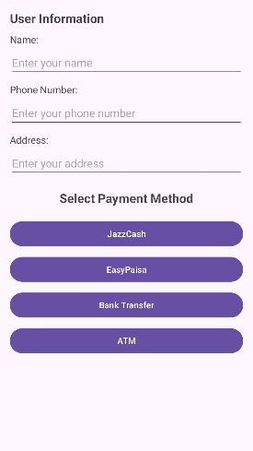

# **Payment Activity**

|  |  |
| --- | --- |
| **XML** | **JAVA** |
| <?xml version="1.0" encoding="utf-8"?> <ScrollView  xmlns:android="http://schemas.android.com/apk/res/android"  android:layout_width="match_parent"  android:layout_height="match_parent">   <LinearLayout  android:layout_width="match_parent"  android:layout_height="wrap_content"  android:orientation="vertical"  android:padding="16dp">   <!-- User Information Section -->  <TextView  android:layout_width="wrap_content"  android:layout_height="wrap_content"  android:text="User Information"  android:textSize="20sp"  android:textStyle="bold"  android:layout_marginBottom="10dp" />   <!-- Name Input -->  <TextView  android:layout_width="wrap_content"  android:layout_height="wrap_content"  android:text="Name:"  android:layout_marginBottom="5dp"  android:textSize="16sp" />   <EditText  android:id="@+id/userName"  android:layout_width="match_parent"  android:layout_height="wrap_content"  android:hint="Enter your name"  android:inputType="textPersonName"  android:layout_marginBottom="10dp" />   <!-- Phone Number Input -->  <TextView  android:layout_width="wrap_content"  android:layout_height="wrap_content"  android:text="Phone Number:"  android:layout_marginBottom="5dp"  android:textSize="16sp" />   <EditText  android:id="@+id/userPhone"  android:layout_width="match_parent"  android:layout_height="wrap_content"  android:hint="Enter your phone number"  android:inputType="phone"  android:layout_marginBottom="10dp" />   <!-- Address Input -->  <TextView  android:layout_width="wrap_content"  android:layout_height="wrap_content"  android:text="Address:"  android:layout_marginBottom="5dp"  android:textSize="16sp" />   <EditText  android:id="@+id/userAddress"  android:layout_width="match_parent"  android:layout_height="wrap_content"  android:hint="Enter your address"  android:inputType="textPostalAddress"  android:layout_marginBottom="20dp" />   <!-- Payment Method Section -->  <TextView  android:layout_width="wrap_content"  android:layout_height="wrap_content"  android:text="Select Payment Method"  android:textSize="20sp"  android:textStyle="bold"  android:layout_gravity="center"  android:layout_marginBottom="20dp" />   <!-- Buttons -->  <Button  android:id="@+id/jazzCashButton"  android:layout_width="match_parent"  android:layout_height="wrap_content"  android:text="JazzCash"  android:layout_marginBottom="10dp" />   <Button  android:id="@+id/easyPaisaButton"  android:layout_width="match_parent"  android:layout_height="wrap_content"  android:text="EasyPaisa"  android:layout_marginBottom="10dp" />   <Button  android:id="@+id/bankTransferButton"  android:layout_width="match_parent"  android:layout_height="wrap_content"  android:text="Bank Transfer"  android:layout_marginBottom="10dp" />   <Button  android:id="@+id/atmButton"  android:layout_width="match_parent"  android:layout_height="wrap_content"  android:text="ATM" />  </LinearLayout> </ScrollView> | package com.example.bookstoreproject;  import android.os.Bundle; import android.view.View; import android.widget.Button; import android.widget.EditText; import android.widget.Toast;  import androidx.appcompat.app.AppCompatActivity;  public class PaymentActivity extends AppCompatActivity {   @Override  protected void onCreate(Bundle savedInstanceState) {  super.onCreate(savedInstanceState);  setContentView(R.layout.activity_payment);   // Get references to input fields  EditText userName = findViewById(R.id.userName);  EditText userPhone = findViewById(R.id.userPhone);  EditText userAddress = findViewById(R.id.userAddress);   // Get references to buttons  Button jazzCashButton = findViewById(R.id.jazzCashButton);  Button easyPaisaButton = findViewById(R.id.easyPaisaButton);  Button bankTransferButton = findViewById(R.id.bankTransferButton);  Button atmButton = findViewById(R.id.atmButton);   // Button click listeners  jazzCashButton.setOnClickListener(view -> showToast("JazzCash", userName, userPhone, userAddress));  easyPaisaButton.setOnClickListener(view -> showToast("EasyPaisa", userName, userPhone, userAddress));  bankTransferButton.setOnClickListener(view -> showToast("Bank Transfer", userName, userPhone, userAddress));  atmButton.setOnClickListener(view -> showToast("ATM", userName, userPhone, userAddress));  }   // Helper method to show toast message  private void showToast(String method, EditText userName, EditText userPhone, EditText userAddress) {  String name = userName.getText().toString();  String phone = userPhone.getText().toString();  String address = userAddress.getText().toString();   if (name.isEmpty() || phone.isEmpty() || address.isEmpty()) {  Toast.makeText(this, "Please fill out all fields", Toast.LENGTH_SHORT).show();  } else {  String message = "Checkout via " + method + ":\n"  + "Name: " + name + "\n"  + "Phone: " + phone + "\n"  + "Address: " + address;  Toast.makeText(this, message, Toast.LENGTH_LONG).show();  }  } } |

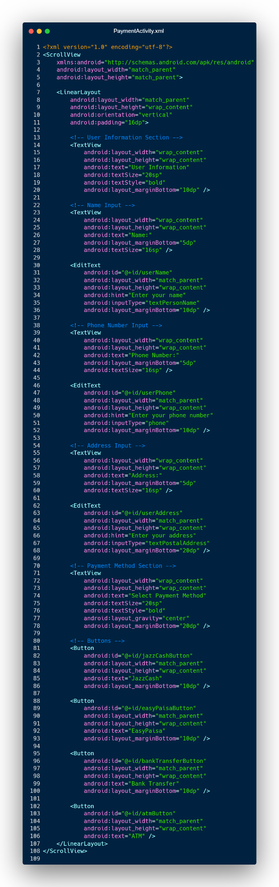

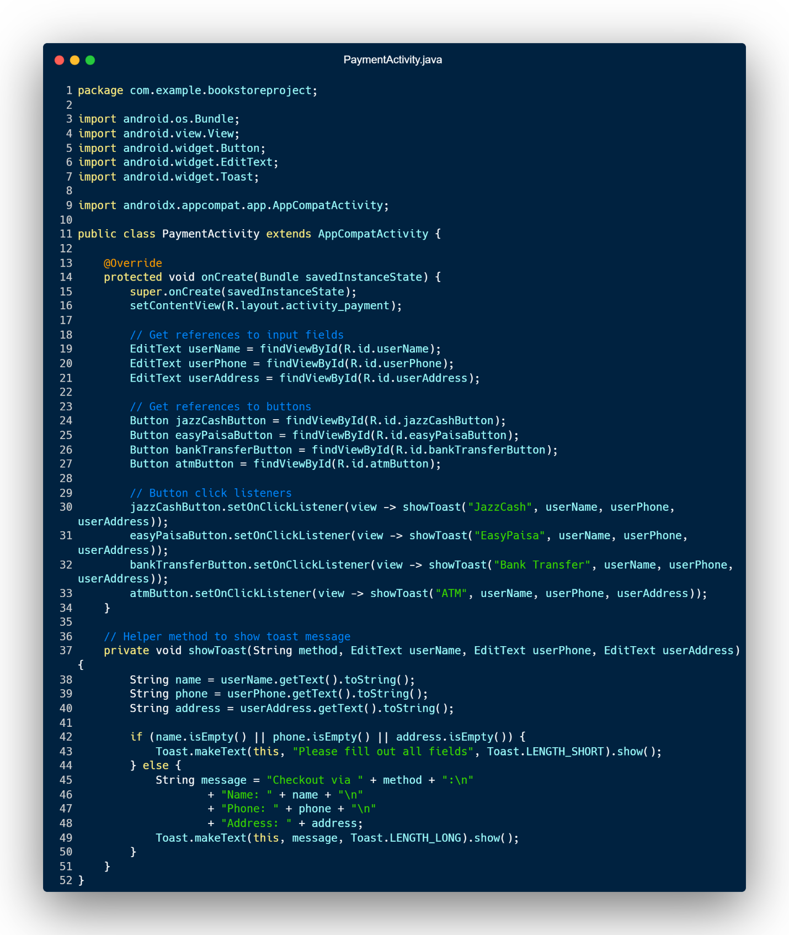

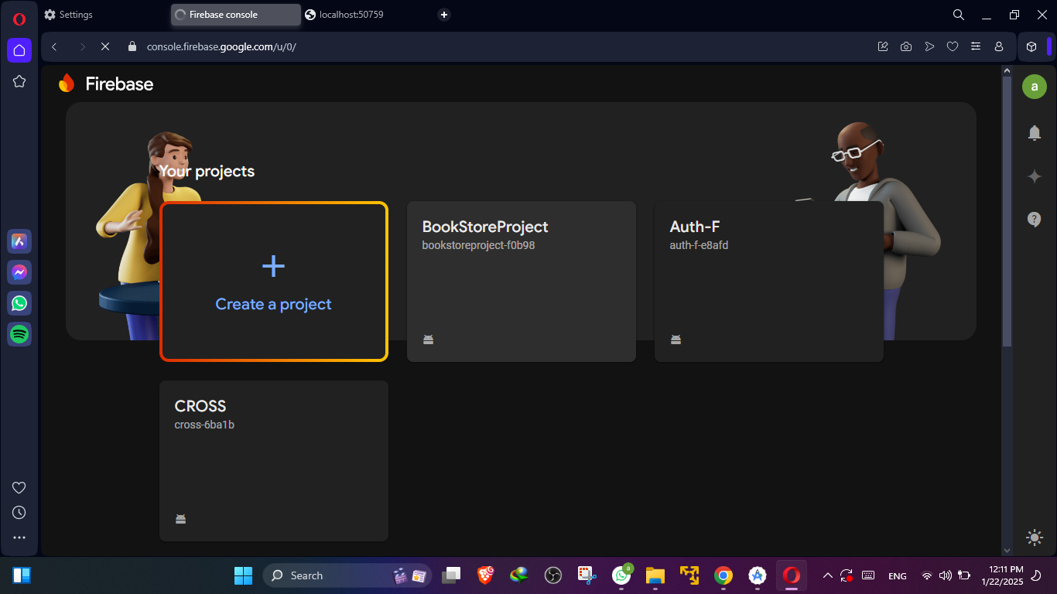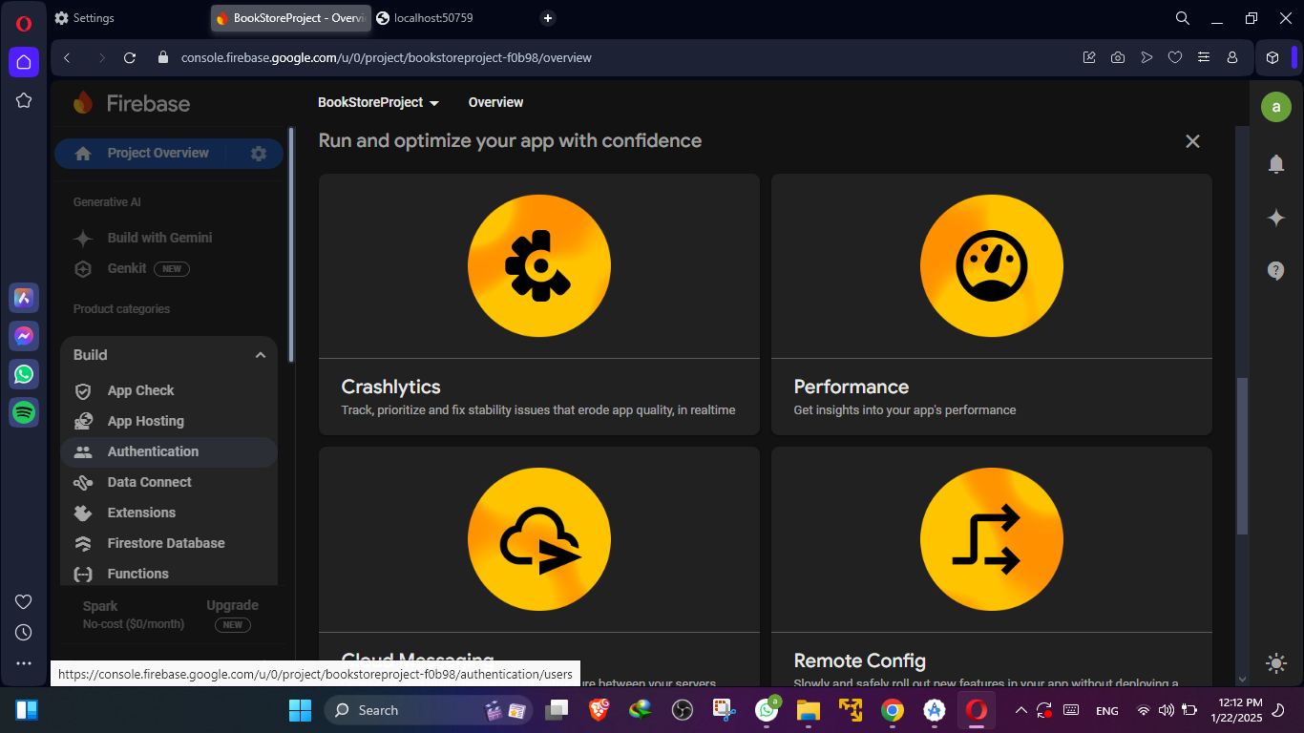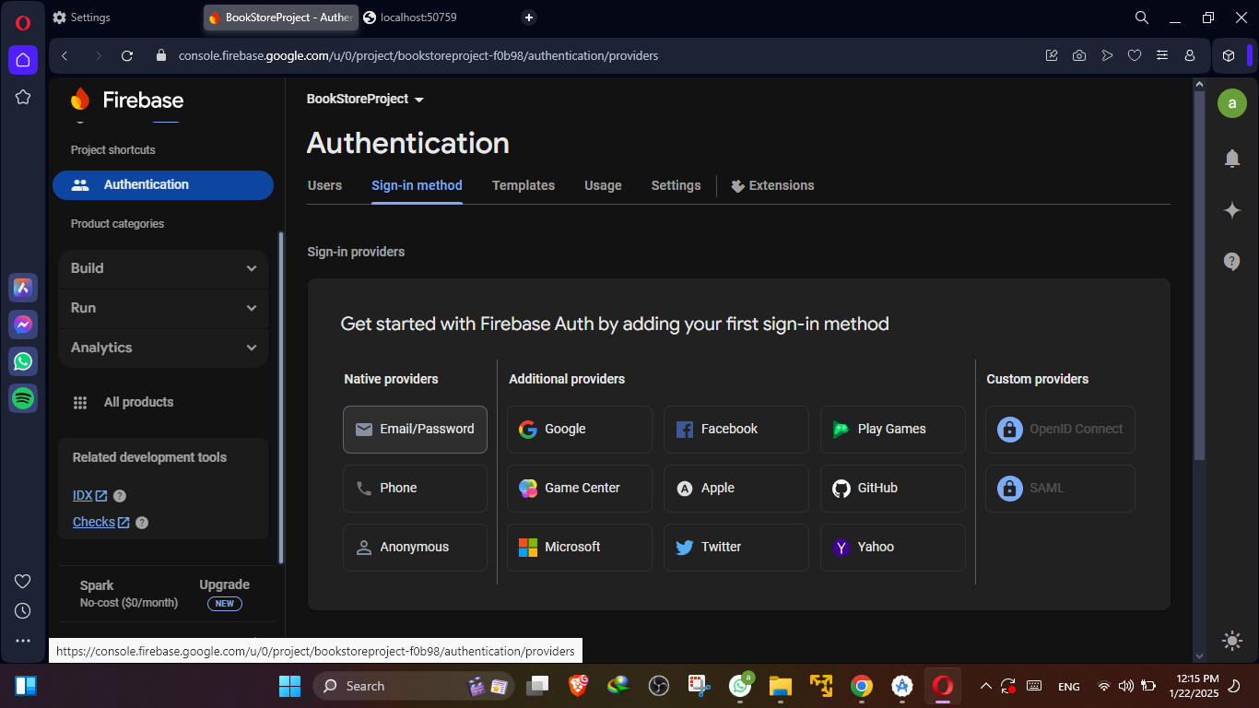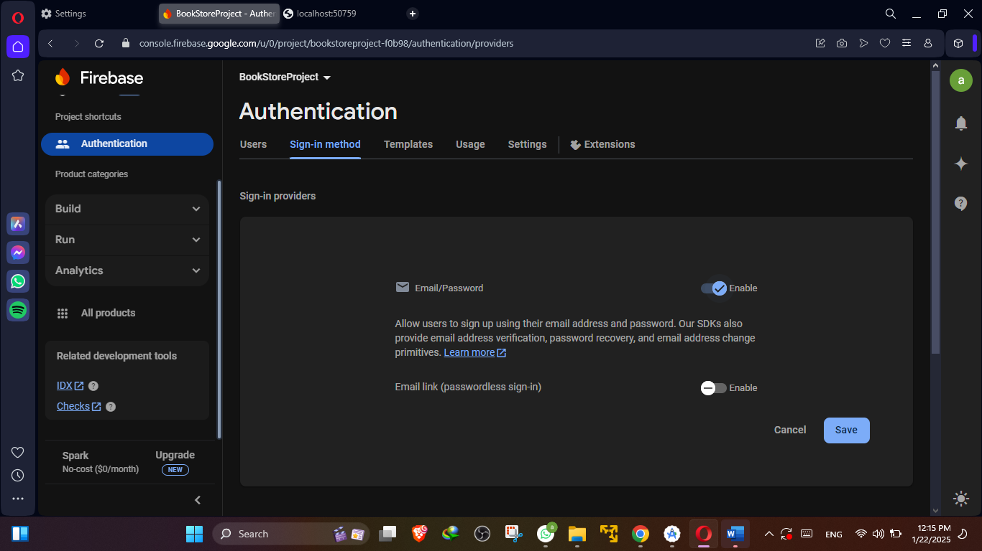

For check the JSON file

